As I mentioned, this week had a lot of side work. I did convert the threshold function to be based on Pk. I also changed the dynamics from x and y velocity to velocity and heading angle which has made the probability function cleaner.

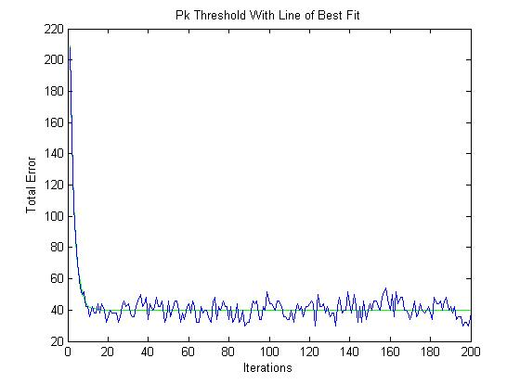

The equation of the line of best fit is $Y=264.8e^{-0.4482x}+40$. For testing I picked a desired number of agents per target and calculated the required Pk based on that and arbitrary weapon effectiveness and attrition rates. I also made a plot with the average difference between the desired Pk and the current Pk over the same 200 iterations.

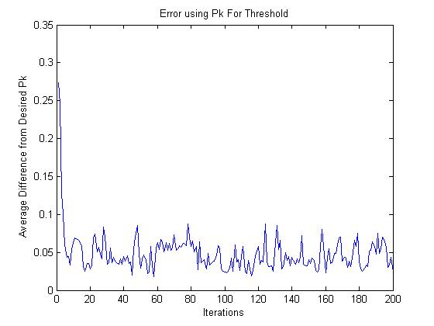

Next week I plan to run a lot of monte carlo simulations on the methods I’ve looked at so far and see what parameters work best when there are too many agents, too few and with varying attrition rates/weapon efficacies.